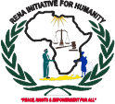
BACKGROUND INFORMATION:
RENA INITIATIVE FOR HUMANITY (RENA abbreviated for “Rights and Empowerment Network Africa”) is a registered Indigenous Network based non-governmental, not-for-profit organization committed to ‘empowering and promoting positive change to the vulnerable communities living in Africa to live a peaceful and harmonious life. The organization was formed by a group of Rights Activist who felt the need to advocate for fundamental rights, which are included in (CAP 4 of the constitution of the Republic of Uganda, “Protection and Promotion of fundamental and other human rights and freedom”, “Rights to property ownership, succession, and inheritance right”) and empowerment of the most vulnerable marginalized community (children women and youth) who are being suppressed by the looming state of, poverty, right abuse/violations, ignorance and disease in Africa.

VISION: A peaceful and healthy society that enjoys and upholds a culture of rights, democracy, good governance, and empowerment.

MISSION: Empower and promote a transformation process among the community in making positive changes in behavior, beliefs, and attitudes that have been ruined because of negative situations or environment and strengthen the capacity of the human rights defenders in protecting grass root women, youth, children, human rights defenders’ movements and mainstreaming safety, security and protection management in their work/life.

GOAL: To establish a Network with community setup where community especially women and children can enjoy their rights, access socio-economic services, social justice, better health care and education services through their initiatives to promote positive response and preventive measures to HIV/AIDS, violence against women and children, Sexual and Gender Based Violence (S.G.B.V.) and any form of rights abuse and violation.

OBJECTIVES:
- To advocate for rights, protection, and safety of human rights defenders and other vulnerable people.
- Promote peace-building, leadership, good governance democracy and conflict resolution/management
- Empowering vulnerable communities to prevent GBV/HIV/AIDS, violence against women and girls
- Promoting education, and reproductive health rights of women and girls.
- Engaging community in food security, nutrition, and livelihood diversification.
- Establish a vocational skills training Centre for skills training, apprenticeships, and counseling guidance on psychosocial and economic empowerment.
- Advocate for environmental protection and conservation.
CORE VALUE:
- Integrity, Accountability and Transparency, Gender equity and equality, Teamwork, Respect for Human rights and Justice.
TARGET GROUPS:
- Primary targets: Children, Women, Youth, and Human rights defenders
- Secondary targets: State actors (JLOS, Line ministries and departments), non-state actors (Partners, civil society organizations and private sectors), Employers, Labour exporters and partners and Researchers and scholars.
STRATEGIES:
- Research, advocacy and documentation.
- Capacity building -training and empowerment.
- Networking and building alliances

MAJOR SECTORS OF WORK:
- Rights, Protection, Security, and Safety (Rights and protection)
- Socio-economic empowerment of women and youth in livelihood, food security and micro-crediting management. (socio-economic empowerment)
- Community health support, Nutrition, Gender Based Violence prevention, and HIV/AIDS Component (Community Health)
- Peacebuilding, leadership, Democracy Good governance (Peace, Governace, Democracy and Reconciliation)
- Promoting education for all with special attention to women and girl child education (Education).
- Centre-based services, (reception, counseling and referral, follow-up of clients)

ACHEIVEMENTS TODATES:
PHOTOGRAPH 1:
Community engagement on GBV and HIV/AIDS prevention at Koch-Goma Sub-County Nwoya District.
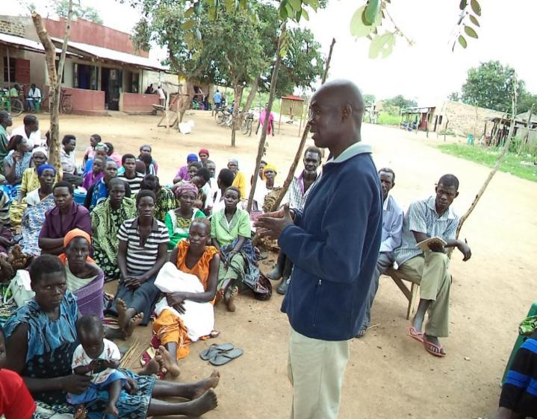
PHOTOGRAPH 2:
Selection youth for skills training Programme in Gulu City by Facilitator Jenny.
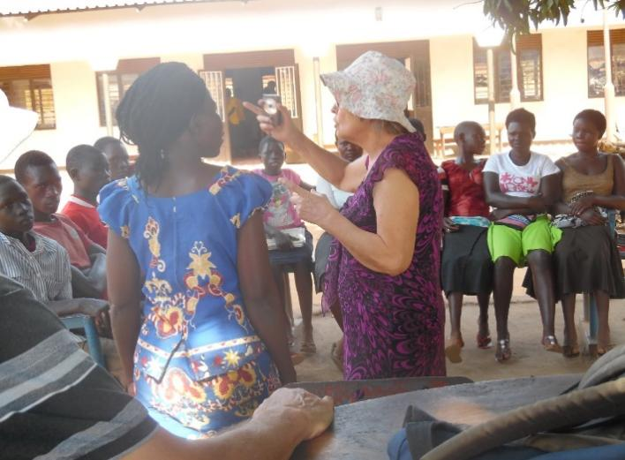

PHOTOGRAPH 3:
Selection of Youth for Skills Training Programme in Gulu City.
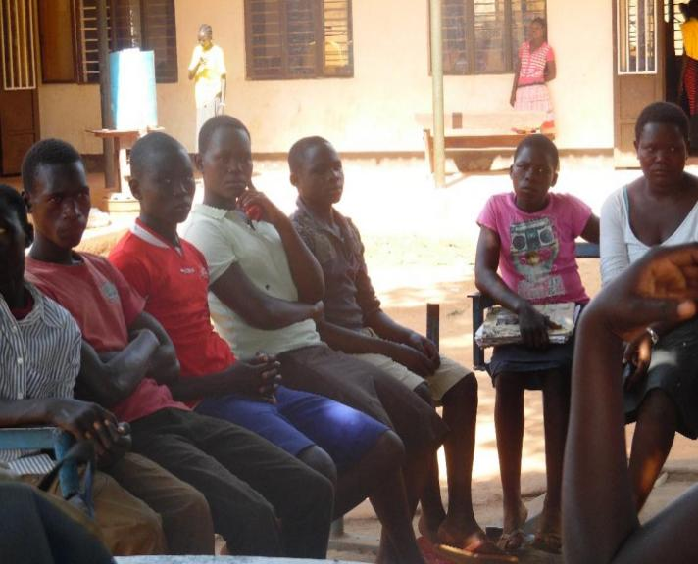
PHOTOGRAPH 4:
Promotion and popularization of Community-Led Development:
- Community action cycle for community intervention (CAC)
- Advocates for respect of rights of women migrants, sex workers, and street youths/children.
- Protecting women against abuse, exploitation, and violence in adverse forms and settings.
- Capacity building for human rights defenders (special attention to women) through training, exchange/support visits, and short course programs.
- Advocacy on positive policies /laws, networking, and civic empowerment on women's rights.
- Provide information on protection and security tips through the digital platform
- Partnership with other rights-based organizations to provide security counseling and legal referrals.
- Provision of community information counseling and legal referrals to enable community access right information while seeking legal redress.
- Work with stakeholders and communities to monitor, prevent human trafficking and exploitation along the border.
COMPLIANCE:
- Documented the relevant policies that governed the operations and registration with the NGO Board Ministry of Internal Affairs
- Filed returns to URSB regulations for FY 2021/2022 & 2022/2023
SUSTAINABILITY:
- Engaged in the production of chalks for schools.
- Community saving and credit facility
FUNDRAISING OPPORTUNITIES:
- Lobby through written proposals and submit them to partners as a means of fundraising portfolio for further development.
- Carry out research and documentation on issue of security and safety of Women and HRDs
TASKS:
- Capacity building in organizational development
- Lobbying for funding opportunities
- Networking and alliance-building with partners.
- Implementing community sensitization on reproductive health rights and violence prevention interventions
- Continuous survey on the effect of violence against women and policy analysis on the same.
CONTACTS PERSONS:
Christine Akumu
CHAIRPERSON BOARD OF DIRECTORS
&
Francis Arop Omuk
EXECUTIVE DIRECTOR
RENA INITIATIVE FOR HUMANITY
Rights and Empowerment Network Africa Initiative for Humanity.
Plot 56 Sira Dongo Road, P.O. Box 235, Gulu, Uganda Telephone Contacts: +256 (0) 782370616/772720165
E-mail: renainitiativesforhumanity2021@gmail.com, info@renainitiativeafrica.org
Web Page: www.renainitiativeafrica.org

